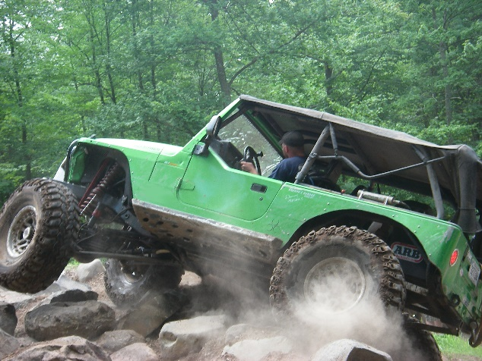

JEEP ADVENTURE WEEKEND!

JUNE 13th and JUNE 14th, 2015, at TROLLHAUGEN SKI AREA, Dresser, WI

Registration and payment due by June 10th.

Send this COMPLETED FORM ALONG WITH YOUR PAYMENT TO:

Park Chrysler Jeep - Attn: Carol @ 1408 W. Hwy 13, Burnsville, MN 55337

Contact Carol at 952-890-5337, fax: 952-890-5360 or email at [carol@parkchryslerjeep.com](mailto:carol@parkchryslerjeep.com)

VEHICLE DRIVER:___________________________________ __________

ADDRESS:____________________________________________________________

CELL PHONE:___________________________EMAIL:_________________________

TYPE OF JEEP:__________________________EXPERIENCE LEVEL:____________

SATURDAY TRAIL DAY - INCLUDES DINNER & ACTIVITIES for DRIVER _____$80.00

Names of passengers age 13 Over:_______________ _____________ __________

Trail riding, dinner & activities - **# of additional passengers:_________**X $15.00 =________

Names of 12 and Unders:__ _______________________________NO CHARGE

SATURDAY NIGHT CAMPING – per site $20.00

TYPE OF CAMPING SITE NEEDED (please circle) TENT CAMPER____RV______

DO YOU NEED A POWER HOOK-UP?______________________________________

SUNDAY TRAIL DAY- 2 OPTIONS

OPTION #1:___SUNDAY AS A CONTINUATION OF SATURDAY (all inclusive)_________$30.00

OPTION #2:___SUNDAY TRAIL RIDING ONLY (was not riding Saturday, all inclusive)___$50.00

PLEASE CALCULATE YOUR TOTAL:___________

MAKE CHECKS PAYABLE TO PARK CHRYSLER JEEP. WE ACCEPT VISA, MC, AM EX, DISC. YOU MAY CALL IN YOUR PAYMENT.